INTRODUCTION
8051 MICROCONTROLLER BOARD
Hardware description
The evaluation board consists of two major parts and provides a function to convert the
parallel data bus to RS232 serial port and vice versa. Also, it provides an in-system
programming function.

The functions of the three two parts are described as follows:
• Philips P89v51RD2/P89c51RD2 is an 8051 microcontroller. The microcontroller connection to the RS232 is through the serial data bus and control signals - address, write, read, reset, and chip select signals.

• Philips RS-232 drivers/receivers are the transceivers. The first one allows the
microcontroller to be in-system programmed through a PC’s serial port such as
COM1. The RS-232 mainlyconsists of two sections: drivers (transmitters) and receivers. The drivers convert the CMOS-logic output levels to RS-232 signals, whereas the receivers convert theRS-232 signals to CMOS-logic output levels.

Software description
The programming of the demo board can be done by writing firmware code requires the
following software.
• Raisonance is one of the embedded system vendors that provide the development
tools for the 8051 microcontroller. The software compiles the firmware code and generates an ’Intel Hex’ file. Flash Magic is a free Windows application software that allows easy programming of Philips Flash Microcontrollers. The software loads the ’Intel Hex’ file to the microcontroller by using its in-system programming mode communicating through serial port.

In-system programming mode
Philips P89C51RD2/P89V51RD2 microcontroller has an on-chip Flash program memory with ISP (In-System Programming), which allows the microcontroller to be programmed without removing the microcontroller from the board and also the microcontroller, which previously programmed can be reprogrammed without removal from the board.
The microcontroller must be powered up in a special ’ISP mode’ to perform the ISP
operation. The ISP mode allows the microcontroller to communicate with a host device such as PC through a serial port. The host sends commands and data to the microcontroller. The commands can be erase, read, and write. After the completion of the ISP operation, the microcontroller is reconfigured and has to be reset or power cycled so the microcontroller will operate normally. The ISP programming for the device can be done using a Windows application software,which uses an Intel Hex file as input to program it.

Conclusion
The use of the evaluation kit allows the user to understand how the different external world devices are interfacing with a microcontroller such as 8051. The board shows the different peripheral devices. Which are describe below.

PICTURE OF 8051 MICROCONTROLLER BOARD

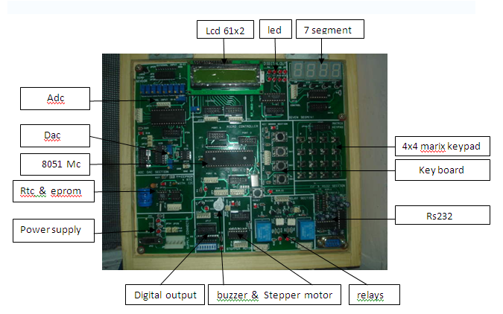

8051 microcontroller (P89C51RD2/P89V51RD2) section

The P89C51RB2/RC2/RD2 device contains a non-volatile 16kB/32kB/64kB Flash program memory that is both parallel programmable and serial In-System and In-Application Programmable. In-System Programming (ISP) allows the user to download new code while the microcontroller sits in the application.
In-Application Programming (IAP) means that the microcontroller fetches new program code and reprograms itself while in the system. This allows for remote programming over a modem link. A default serial loader (boot loader) program in ROM allows serial
In-System programming of the Flash memory via the UART without the need for a loader in the Flash code. For In-Application Programming, the user program erases and reprograms the Flash memory by use of standard routines contained in ROM.
This device executes one machine cycle in 6 clock cycles, hence providing twice the speed of a conventional 80C51. An OTP configuration bit lets the user select conventional 12 clock timing if desired. This device is a Single-Chip 8-Bit Microcontroller manufactured in advanced CMOS process and is a derivative of the 80C51 microcontroller family. The instruction set is 100% compatible with the 80C51 instruction set. The device also has four 8-bit I/O ports, three 16-bit timer/event counters, a multi-source, four-priority-level, nested interrupt structure, an enhanced UART and on-chip oscillator and timing circuits. The added features of the P89C51RB2/RC2/RD2 makes it a powerful microcontroller for applications that require pulse width modulation, high-speed I/O and up/down counting capabilities such

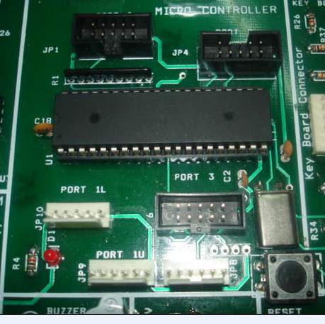
P89C51RD2/
P89V51RD22)
()
JP1 PORT P0
JP6 PORT P3
JP9 PORT 1(upper)

()
Jp10 PORT 1(lower)
8051 reset
JP4 PORT P2

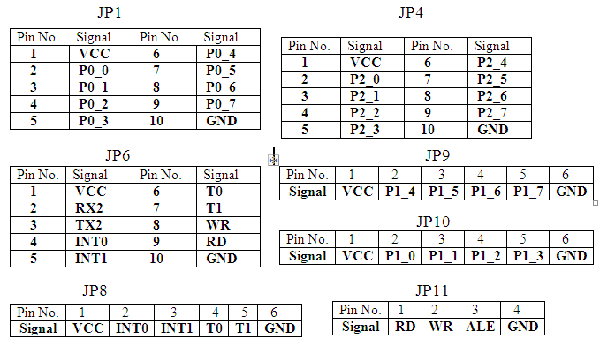CONNECTIONS- In this hardware the ports of 8051 microcontroller are out on connectors jp1,j p4, jp6, jp9 & jp10. There is flexibility to connect any port of 8051 with any section available on hardware board. port1 is devided into lower and upper for more flexibility to use. For the details of used select lines(i/o lines) for different hardware sections please study our example programs before work on hardware.
Abbrivations use-
1L- lower four bits of port 1.
1u - upper four bits of port 1.

Pin details for on board 6 & 10 pin connectors, all 6 pin & 10 pin connectors available on hardware board are standard pin specified according to images shown below.
6 pin connector

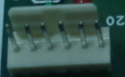

3 2 1 0
Port bits
Gnd
Vcc

10 pin box header connector

Port bits
0 2 4 6

Gnd pin 10
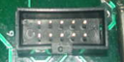
Vcc pin 1

1 3 5 7
Port bits

See from cut side

40 pin dip package 8051 pin diagram

8051Microcontroller Board has on board
- ADC section.
- RTC & EEPROM section.
- DISPLAY (LCD, LED, & 7-SEG) section.
- INPUT SWITCHES (PUSH BUTTON & DIP SWITCH) section.
- RELAY section.
- BUZZER section
- RS232 SECTION
- 4X4 MATRIX KEYPAD SECTION
- POWER SUPPLY SECTION
- STEPPER MOTOR SECTION
- DAC SECTION

PERIPHERALS

Part No. | Specifications
ADC0809CCN | 8-BIT 8-CHANNEL, 100μs.
RTC DS1307 | 64X8, SERIAL I²C Real Time Clock.
EPROM 24C04 | 4K serial EEPROM.
LCD | 16 x 2 character LCD
BUZZER | 5V
RELAY | 5A/250V AC
DAC0808 | 8 bit+12vdc,-15v dc
STEPPER MOTOR | 5 V
7-SEGMENT | COMMON ANODE
LED | 1.5V

POWER SUPPLY REQUIREMENTS

Voltage Rating | Current Rating
+/- 5 V | 1A
+/- 12V | 1A

8051 Microcontroller Board Features

P89C51RD2/P89V51RD2

Features
• On-chip Flash Program Memory with In-System Programming (ISP) and In-Application Programming (IAP) capability
• Boot ROM contains low-level Flash programming routines for downloading via the UART
• Can be programmed by the end-user application (IAP)
• Parallel programming with 87C51 compatible hardware interface to programmer
• Supports 6-clock/12-clock mode via parallel programmer (default clock mode after Chip Erase is 12-clock)
• 6-clock/12-clock mode Flash bit erasable and programmable via ISP
• 6-clock/12-clock mode programmable “on-the-fly” by SFR bit
• Peripherals (PCA, timers, UART) may use either 6-clock or 12-clock mode while the CPU is in 6-clock mode
• Speed up to 20 MHz with 6-clock cycles per machine cycle (40 MHz equivalent performance); up to 33 MHz with 12 clocks per machine cycle
• Fully static operation
• RAM expandable externally to 64 Kbytes
• Four interrupt priority levels
• Seven interrupt sources
• Four 8-bit I/O ports
• Full-duplex enhanced UART
– Framing error detection
– Automatic address recognition
• Power control modes
– Clock can be stopped and resumed
– Idle mode
– Power down mode
• Programmable clock-out pin
• Second DPTR register• Asynchronous port reset
• Low EMI (inhibit ALE)
• Programmable Counter Array (PCA)
– PWM
- Capture/compare

KEY BOARD SECTION
Key board is an input section with 4 switches to give input to microcontroller.with use of keyboard section we can put conditions on microcontroller to give or not give output. In this section a 6 pin connector is provided to connect with microcontroller any port .From right first pin is +5v dc(Vcc),second to fourth are switch select pin,with each pin switch is connected,from left first pin is ground(GND).

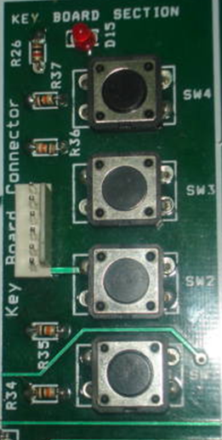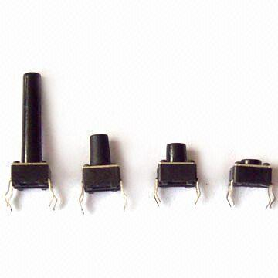
Key board connector
External intrupt

KEY BOARD Different types of key switches

BUZZER SECTION

A Buzzer is output device having +ve and –ve terminals ,which generate a tone when it get high signal on its positive terminal.these devices are capable of geneate sound ,such kind of devices can be used in hardwares like security systems and sensitive equipments to protect them from burn.For example if temperature of particular area rise over than prespecified temperature then a sound should generate.

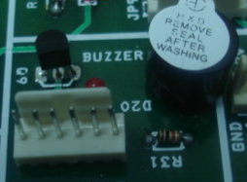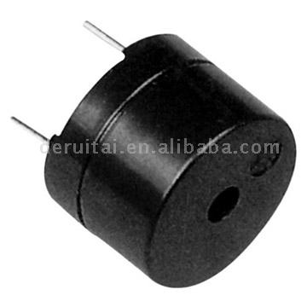
Jp23 Buzzer input connector
Piecoelectric buzzer
Buzzer

CONNECTIONS-Connect jp23 of buzzer section with any port of microcontroller. For details of select pins(used i/o lines) see program of relay buzzer or simple buzzer program.
buzzer or beeper is a signalling device, usually electronic, typically used in automobiles, household appliances such as a microwave oven, or game shows. It most commonly consists of a number of switches or sensors connected to a control unit that determines if and which button was pushed or a preset time has lapsed, and usually illuminates a light on the appropriate button or control panel, and sounds a warning in the form of a continuous or intermittent buzzing or beeping sound. Initially this device was based on an electromechanical system which was identical to an electric bell without the metal gong (which makes the ringing noise). Often these units were anchored to a wall or ceiling and used the ceiling or wall as a sounding board. Another implementation with some AC-connected devices was to implement a circuit to make the AC current into a noise loud enough to drive a loudspeaker and hook this circuit up to a cheap 8-ohm speaker. Nowadays, it is more popular to use a ceramic-based piezoelectric sounder which makes a high-pitched tone. Usually these were hooked up to "driver" circuits which varied the pitch of the sound or pulsed the sound on and off.

ANALOG TO DIGITAL CONVERTER (ADC0809)

ADC General Description:

The ADC0809 Data acquisition component is a monolithic CMOS device with an 8-bit analog-to-digital converter, 8 channel multiplexer and microprocessor compatible control logic. The 8-bit A/D converter uses successive approximation as the conversion technique. The converter features a high impedance chopper stabilized comparator, a 256R voltage divider with analog switch tree and a successive approximation register. The 8-bit Channel multiplexer can directly access any of 8 segnal-ended analog signals.
The device eliminates the need for external zero and full scale adjustments. Easey interfacing to microprocessors input and latched TTL TRI-STATE output.
The design of the ADC0808,ADC0809 has been optimized by incorporating the most desirable aspects of several A/D conversion techniques. The ADC0808, ADC0809 offers high speed, high accuracy, minimal temperature dependence, excellent long term accuracy and repeatability, and consumes minimal power. These features make this device ideally suited to application from process and machine control to consumer and automotive application. For 16-channel multiplexer with common output (sample/hold port) see ADC0816 data sheet. (See AN274 for more information.)

CIRCUIT DIAGRAM FOR ADC

Input to 8 channels
IN0 IN1 IN2 IN3 IN4 IN5 IN6 IN7

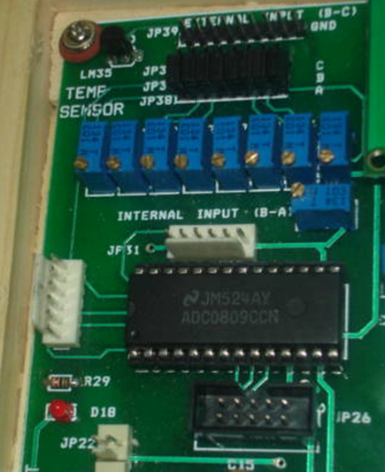
Jp 26
8 bit digital out
Jp 31
SET0 SET1 SET2 CLK
0 1 2 3

Jp 28
EOC ALE SOC OE
4 5 6 7

LM 35 temperature sensor
ADC 0809

8 varaiable resistors are provided in adc section , each is connected to channel input. IN0,IN1,IN2,IN3.IN4,IN5,IN6,IN7 to give input to adc .Either input can give from out side by shifting jumpers between jp36 and jp37 from 1 to 8( left to right ).jumpers can be selected optionally according to channel selection(for example if choose channel 4 then can shift jumper 4 from left to right ) .connect input from outside to any pin number from 2 to 8 of jumper jp39 . First number pin of jp39 is reserved for LM35 which is connected to first channel input IN0.On board temperature sensor LM35 is provided as input source to adc. To get input from LM35 shift only first jumper between jp36 and jp37 from left.

Features:
- Easy interface to all microprocessors
- Operates ratio metrically or with 5 VDC or analog span
- adjusted voltage reference
- No zero or full-scale adjust required
- 8-channel multiplexer with address logic
- 0V to 5V input range with single 5V power supply
- Outputs meet TTL voltage level specifications
- ADC0808 equivalent to MM74C949
- ADC0809 equivalent to MM74C949-1

Key Specifications
- Resolution 8 Bits
- Total Unadjusted Error ±1⁄2 LSB and ±1 LSB
- Single Supply 5 VDC
- Low Power 15 mW
- Conversion Time 100

RS232 SECTION
This section is on board to program the microcontroller through pc serial port either u can use usb to serial convertor to program microcontroller chip.
The Serial Port is harder to interface than the Parallel Port. In most cases, any device you connect to the serial port will need the serial transmission converted back to parallel so that it can be used. This can be done using a UART. On the software side of things, there are many more registers that you have to attend to than on a Standard Parallel Port. (SPP)
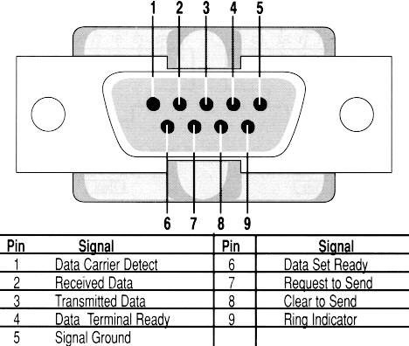
So what are the advantages of using serial data transfer rather than parallel?
1. | Serial Cables can be longer than Parallel cables. The serial port transmits a '1' as -3 to -25 volts and a '0' as +3 to +25 volts where as a parallel port transmits a '0' as 0v and a '1' as 5v. Therefore the serial port can have a maximum swing of 50V compared to the parallel port which has a maximum swing of 5 Volts. Therefore cable loss is not going to be as much of a problem for serial cables than they are for parallel.  RS232 SECTION  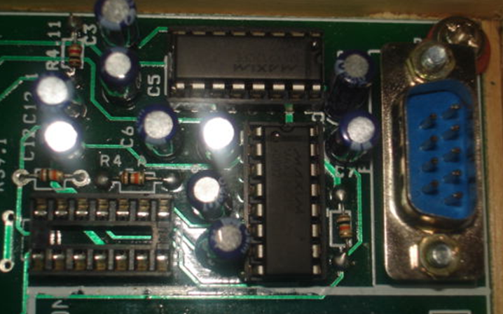  9 pin D connector to program 8051
2. | You don't need as many wires than parallel transmission. If your device needs to be mounted a far distance away from the computer then 3 core cable (Null Modem Configuration) is going to be a lot cheaper that running 19 or 25 core cable. However you must take into account the cost of the interfacing at each end.
3. | Infra Red devices have proven quite popular recently. You may of seen many electronic diaries and palmtop computers which have infra red capabilities build in. However could you imagine transmitting 8 bits of data at the one time across the room and being able to (from the devices point of view) decipher which bits are which? Therefore serial transmission is used where one bit is sent at a time. IrDA-1 (The first infra red specifications) was capable of 115.2k baud and was interfaced into a UART. The pulse length however was cut down to 3/16th of a RS232 bit length to conserve power considering these devices are mainly used on diaries, laptops and palmtops.
4. | Microcontroller's have also proven to be quite popular recently. Many of these have in built SCI (Serial Communications Interfaces) which can be used to talk to the outside world. Serial Communication reduces the pin count of these MPU's. Only two pins are commonly used, Transmit Data (TXD) and Receive Data (RXD) compared with at least 8 pins if you use a 8 bit Parallel method (You may also require a Strobe).

LCD DISLAY SECTION
A liquid crystal display (LCD) is a thin, flat panel used for electronically displaying information such as text, images, and moving pictures. Its uses include monitors for computers, televisions, instrument panels, and other devices ranging from aircraft cockpit displays, to every-day consumer devices such as video players, gaming devices, clocks, watches, calculators, and telephones. Among its major features are its lightweight construction, its portability, and its ability to be produced in much larger screen sizes than are practical for the construction of cathode ray tube (CRT) display technology. Its low electrical power consumption enables it to be used in battery-powered electronic equipment. It is an electronically-modulated optical device made up of any number of pixels filled with liquid crystals and arrayed in front of a light source (backlight) or reflector to produce images in color or monochrome. The earliest discoveries leading to the development of LCD technology date from 1888. By 2008, worldwide sales of televisions with LCD screens had surpassed the sale of CRT units.

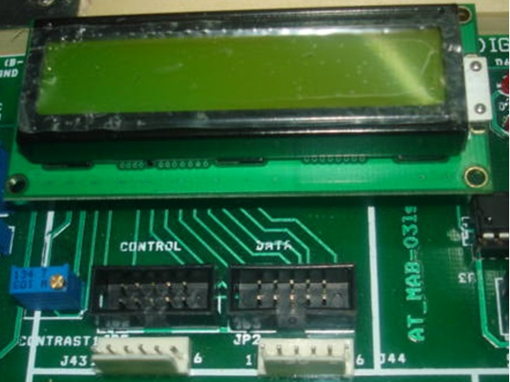
Jp44 4 bit data port
Jp 31 2 bit control rs & e
Jp5 2 bit control rs & e
JP2 8 bit data port

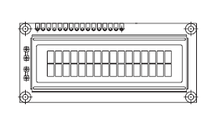
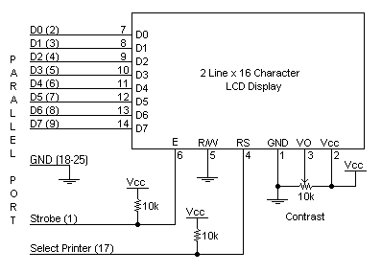
CONNECTIONS- Connect any port of 8051(carrying data) from microcontroller with jp2(in case of 8 bit data mode )and with jp44(in case of 4 bit data mode) data port of lcd (D0-D7) and control port with jp5(0-RS and 1-E) or jp31(0-RS and 1-E) of lcd.For more details see program of lcd display.
FEATURES
• 5 x 8 dots with cursor
• Built-in controller (KS 0066 or Equivalent)
• + 5V power supply (Also available for + 3V)
• 1/16 duty cycle
• B/L to be driven by pin 1, pin 2 or pin 15, pin 16 or A.K (LED)
• N.V. optional for + 3V power supply

LED SECTION
A light-emitting diode (LED) is an electronic light source. LEDs are based on the semiconductor diode. When the diode is forward biased (switched on), electrons are able to recombine with holes and energy is released in the form of light. This effect is called electroluminescence and the color of the light is determined by the energy gap of the semiconductor. The LED is usually small in area (less than 1 mm²) with integrated optical components to shape its radiation pattern and assist in reflection.

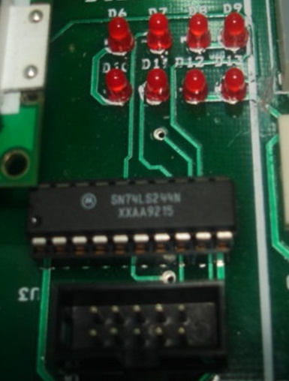
Jp15 led input from 8051
8 led display

CONNECTIONS- connect input (data) port from 8051 with output port port of led section to see output.
LEDs present many advantages over traditional light sources including lower energy consumption, longer lifetime, improved robustness, smaller size and faster switching. However, they are relatively expensive and require more precise current and heat management than traditional light sources.
Applications of LEDs are diverse. They are used as low-energy indicators but also for replacements for traditional light sources in general lighting and automotive lighting. The compact size of LEDs has allowed new text and video displays and sensors to be developed, while their high switching rates are useful in communications technology.
SEVEN SEGMENT DISLAY SECTION
A seven-segment display -less commonly known as a seven-segment indicator, is a form of electronic display device for displaying decimal numerals that is an alternative to the more complex dot-matrix displays. Seven-segment displays are widely used in digital clocks, electronic meters, and other electronic devices for displaying numerical information.
Concept and visual structure -The individual segments of a seven-segment display.A seven segment display, as its name indicates, is composed of seven elements. Individually on or off, they can be combined to produce simplified representations of the arabic numerals. Often the seven segments are arranged in an oblique, or italic, arrangement, which aids readability.
Each of the numbers 0, 6, 7 and 9 may be represented by two or more different glyphs on seven-segment displays.
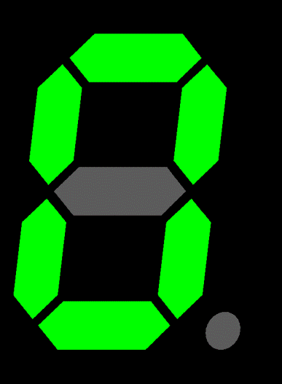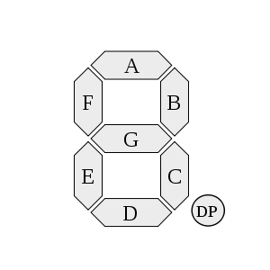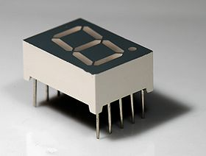
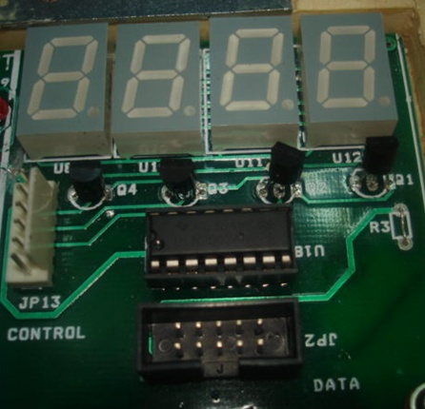
Common anode 7 seg.
Jp21 data port
Jp13 control port

CONNECTIONS- connect data carrying port of 8051 with jp21 data port of 7 segment section and control port with jp13 of seven segment section to see output.
The seven segments are arranged as a rectangle of two vertical segments on each side with one horizontal segment on the top, middle, and bottom. Additionally, the seventh segment bisects the rectangle horizontally. There are also fourteen-segment displays and sixteen-segment displays (for full alphanumerics); however, these have mostly been replaced by dot-matrix displays.
The segments of a 7-segment display are referred to by the letters A to G, as shown to the right, where the optional DP decimal point (an "eighth segment") is used for the display of non-integer numbers.

RELAY SECTION

A relay is an electrical switch that opens and closes under the control of another electrical circuit. In the original form, the switch is operated by an electromagnet to open or close one or many sets of contacts. It was invented by Joseph Henry in 1835. Because a relay is able to control an output circuit of higher power than the input circuit, it can be considered to be, in a broad sense, a form of an electrical amplifier.

Jp27 input to relay
Gnd 3 2 1 0 Vcc

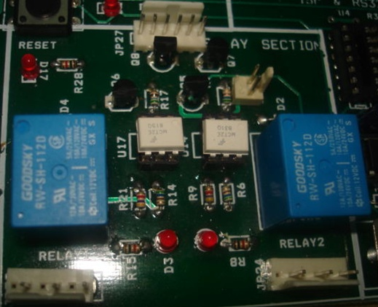
Gnd
+12v
Jp 30 12v dc supply relay

NO C NC
Jp24 relay 1 out
NO C NC
Jp32 relay 2 out

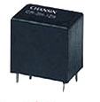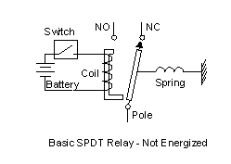
Relay

CONNECTIONS- connect input from microcontroller to jp27 and connect device which want to control with jp32 relay2 out connector or jp22 relay1 out connector. Connect +12v dc supply from power supply section with 2 pin connector jp30(+12v dc to relay coil).
A relay coil is copper wire wound many times on and around a bobbin in which an iron core is situated. When a voltage of sufficient magnitude is impressed across the coil, the coil and core develop magnetism which attracts the armature. The armature, in turn, controls contact movement. Depending on the total length of the wire and its unit cross-sectional area, the coil exhibits a certain amount of resistance to the flow of electric
current. According to Ohm’s Law, for a given amount of resistance, current is directly proportional to voltage. That is:
I = E / R where;
I = current in amperes
E = voltage in volts
R = resistance in ohms
Thus, a 12V DC coil that has 120 ohms of resistance pulls 0.1 amp of current.Some relay coils accept DC voltage, while others accept AC voltage. DC (direct current) voltage has a constant, unchanging value. At any given instant of time, a 12V DC power source measures exactly 12 volts (give or take a few tenths of a volt, normally).

Stepper motor Section

Stepper motors provide a means for precise positioning and speed control without the use of feedback sensors. The basic operation of a stepper motor allows the shaft to move a precise number of degrees each time a pulse of electricity is sent to the motor. Since the shaft of the motor moves only the number of degrees that it was designed for when each pulse is delivered, you can control the pulses that are sent and control the positioning and speed. The rotor of the motor produces torque from the interaction between the magnetic field in the stator and rotor. The strength of the magnetic fields is proportional to the amount of current sent to the stator and the number of turns in the windings. The stepper motor uses the theory of operation for magnets to make the motor shaft turn a precise distance when a pulse of electricity is provided. You learned previously that like poles of a magnet repel and unlike poles attract. Figure 1 shows a typical cross-sectional view of the rotor and stator of a stepper motor. From this diagram you can see that the stator (stationary winding) has eight poles, and the rotor has six poles (three complete magnets). The rotor will require 24 pulses of electricity to move the 24 steps to make one complete revolution. Another way to say this is that the rotor will move precisely 15° for each pulse of electricity that the motor receives. The number of degrees the rotor will turn when a pulse of electricity is delivered to the motor can be calculated by dividing the number of degrees in one revolution of the shaft (360°) by the number of poles (north and south) in the rotor. In this stepper motor 360° is divided by 24 to get 15°. When no power is applied to the motor, the residual magnetism in the rotor magnets will cause the rotor to detent or align one set of its magnetic poles with the magnetic poles of one of the stator magnets. This means that the rotor will have 24 possible detent positions. When the rotor is in a detent position, it will have enough magnetic force to keep the shaft from moving to the next position. This is what makes the rotor feel like it is clicking from one position to the next as you rotate the rotor by hand with no power applied.

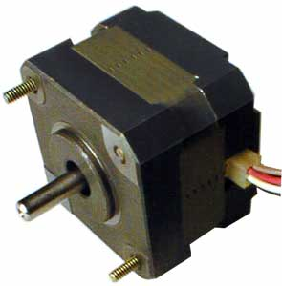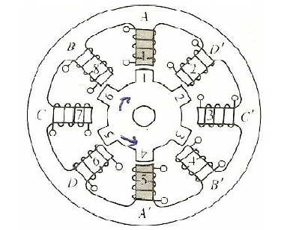

Stepper motor fig 1.

Fig 1. Diagram that shows the position of the six-pole rotor and eight-pole stator of a typical stepper motor.

When power is applied, it is directed to only one of the stator pairs of windings, which will cause that winding pair to become a magnet. One of the coils for the pair will become the North Pole, and the other will become the South Pole. When this occurs, the stator coil that is the North Pole will attract the closest rotor tooth that has the opposite polarity, and the stator coil that is the South Pole will attract the closest rotor tooth that has the opposite polarity. When current is flowing through these poles, the rotor will now have a much stronger attraction to the stator winding, and the increased torque is called holding torque.

CIRCUIT DIAGRAM FOR STEPPER MOTOR

Jp12
8 bit input data from 8051
Jp16
Ouput to stepper motor
Jp12
8 bit input data from 8051
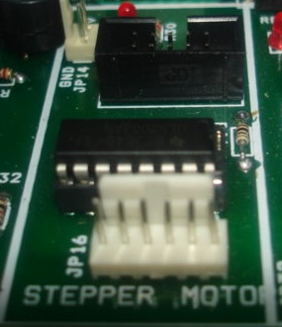
Jp16
Ouput to stepper motor

By changing the current flow to the next stator winding, the magnetic field will be changed 45°. The rotor will only move 15° before its magnetic fields will again align with the change in the stator field. The magnetic field in the stator is continually changed as the rotor moves through the 24 steps to move a total of 360°. Figure 2 shows the position of the rotor changing as the current supplied to the stator changes.

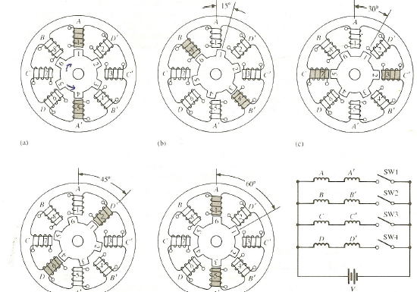

FIGURE 2. Movement of the stepper motor rotor as current is pulsed to the stator. (a) Current is applied to the A and A’ windings, so the A winding is north, (b) Current is applied to B and B’ windings, so the B winding is north, (c) Current is applied to the C and C’ windings, so the C winding is north, (d) Current is applied to the D and D’ windings so the D winding is north. (e) Current is applied to the A and A’ windings, so the A’ winding is north.

CONNECTIONS- Stepper motor section have two connectors, jp16 & jp12 .jp12 is input connector from microcontroller and jp16 is output connector to stepper motor.

DAC0808 SECTION
In electronics, a digital-to-analog converter (DAC or D-to-A) is a device for converting a digital (usually binary) code to an analog signal (current, voltage or electric charge).
A DAC converts an abstract finite-precision number (usually a fixed-point binary number) into a concrete physical quantity (e.g., a voltage or a pressure). In particular, DACs are often used to convert finite-precision time series data to a continually-varying physical signal.
A typical DAC converts the abstract numbers into a concrete sequence of impulses. that are then processed by a reconstruction filter using some form of interpolation to fill in data between the impulses. Other DAC methods (e.g., methods based on Delta-sigma modulation) produce a pulse-density modulated signal that can then be filtered in a similar way to produce a smoothly-varying signal.

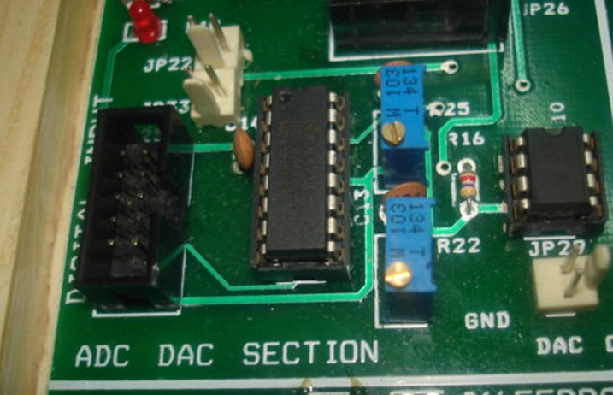

DAC 0808 (8 bit d/a convertor)
The DAC0808 is an 8-bit monolithic digital-to-analog converter (DAC) featuring a full scale output current settling time of 150 ns while dissipating only 33 mW with ±5V supplies. No reference current (IREF) trimming is required for most applications
since the full scale output current is typically ±1 LSB of 255 IREF/256. Relative accuracies of better than ±0.19% assure 8-bit monotonicity and linearity while zero
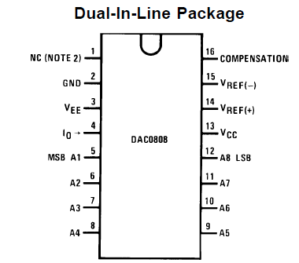
level output current of less than 4 μA provides 8-bit zero accuracy for IREF³2 mA. The power supply currents of the DAC0808 is independent of bit codes, and exhibits essentially constant device characteristics over the entire supply voltage range.
The DAC0808 will interface directly with popular TTL, DTL or CMOS logic levels, and is a direct replacement for the MC1508/MC1408. For higher speed applications, see DAC0800 data sheet.

Features
Relative accuracy: ±0.19% error maximum
Full scale current match: ±1 LSB type Fast settling time: 150 ns typ
Noninverting digital inputs are TTL and CMOS
ompatible
High speed multiplying input slew rate: 8 mA/μs
Power supply voltage range: ±4.5V to ±18V
Low power consumption: 33 mW @ ±5V

DIP switch section

Dip switch section is an digital input section which is used to give digital external input to microcontroller.

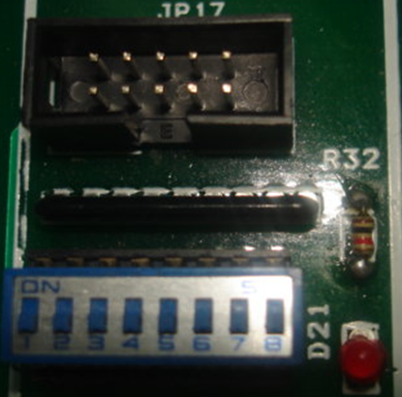
8 way Dip switch
Jp17 Digital output
output output

A DIP switch is a set of manual electric switches that are packaged in a group in a standard dual in-line package (DIP) (the whole package unit may also be referred to as a DIP switch in the singular). This type of switch is designed to be used on a printed circuit board along with other electronic components and is commonly used to customize the behavior of an electronic device for specificsituations.
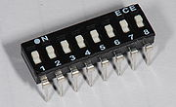
DIP switches are an alternative to jumper blocks. Their main advantages are that they are quicker to change and there are no parts to lose.

DIP switch types
There are many different kinds of DIP switches. Some of the most common are the rotary, slide, and rocker types.
Rotary DIP switches contain multiple contacts, one of which is selected by rotating the switch to align it with a number printed on the package.
The slide and rocker types, which are very common, are arrays of simple SPDT (single-pole, single-throw) contacts, which can be either on or off. This allows each switch to select a one-bit binary value. The values of all switches in the DIP package can also be interpreted as one number. For example, seven switches offer 128 combinations, allowing them to select a standard ASCII character. Eight switches offer 256 combinations, which is equivalent to one byte.
The DIP switch package also has socket pins or mounting leads to provide an electrical path from the switch contacts to the circuit board. Although circuits can use the electrical contacts directly, it is more common to convert them into high and low signals. In this case the circuit board also needs interface circuitry for the DIP switch, consisting of a series of pull-up or pull-down resistors, a buffer, decode logic, and other components. Typically the device's firmware reads the DIP switches. They were also often used on arcade games in the 1980s and early 1990s to store settings, before the advent of cheaper, battery-backed RAM and were very commonly used to set security codes on garage door openers as well as on some early cordless phones. This design, which used up to twelve switches in a group, was used to avoid interference from other nearby door opener remotes or other devices. Current garage door openers use rolling code systems for better security.
These type of switches were used on early video cards for early computers to facilitate compatibility with other video standards. For example, CGA cards allowed for MDA compatibility.
Recently (since the late 1990s), DIP switches have become less common in consumer electronics. Reasons include the trend toward smaller products, the demand for easier configuration through setting screens, and the falling price of non-volatile memory. But DIP switches are still widely used in industrial equipment because they are inexpensive and easy to incorporate into circuit designs, and because they allow settings to be checked at a glance without powering the system on.

4x4 matrix keypad section
Introduction -The aim of this application note is to show how to scan the 4x4 matrix keypad multiplexed. The software attached to this application note scans the pressed key and displays it on the lcd 16x2 display.
Jp40 keypad ouput

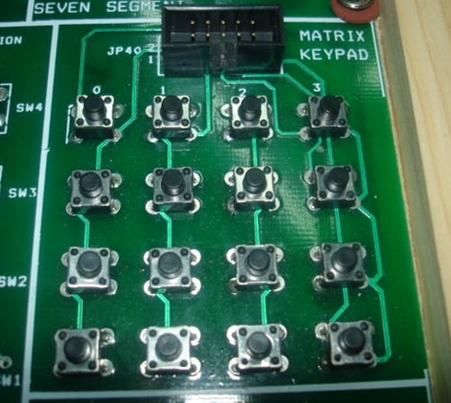
Fig. 1

A 4x4 keypad can be very easily interfaced to the 8051 PORTS (Figure 1). Eight lines (0 - 7) are ssigned to matrix keypad. Four lines (0 - 3) are used to select the columns C1, C2, C3 & C4. The four lines (4 - 7) of same port are used to select rows R1,R2,R3 & R4.

CONNECTIONS- Make connections for lcd display by connecting data and control port of 8051 and connect keypad connector jp40 with 8051 port(selected for keypad interface).for more details how to use see program of matrix keypad.

